# SuperDARN - Introductory Material

This manual serves as a comprehensive guide to maintaining the SuperDARN high frequency radar at SANAE IV. This section of the manual provides a concise background on the SuperDARN Radar, how it works and what it looks for.

## Infrastructure

The radar’s infrastructure consists of 20 antenna masts and a hut which houses all the radar’s transceiver and server equipment, as well as the network and electricity connection to the base infrastructure.

The radar hut is located about 600 m South-East of the base at the centre of the main antenna array, as shown in *Figure 1*. There is a lifeline stretching from the base to the radar hut, as indicated on the map in *Figure 1*.

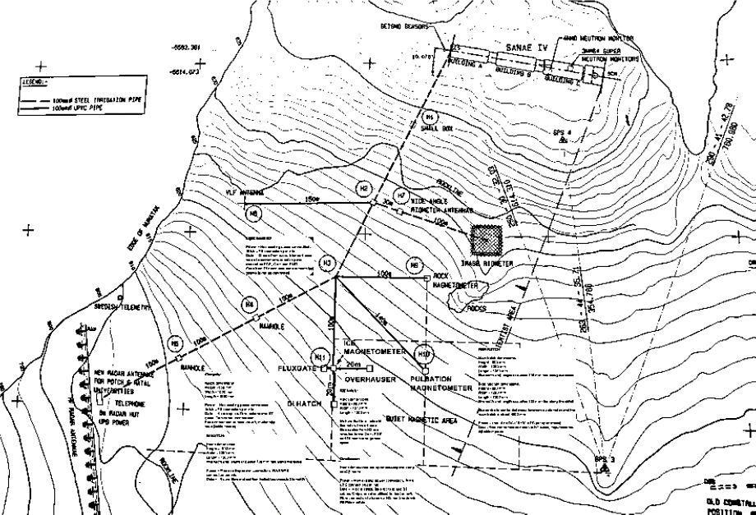

Figure . Map of SANAE IV science area.

Electricity is relayed from the base to the radar hut, from where it is also distributed to the small satellite dome where the ozone radiometer is located. The power is not connected to the base UPSs, so the radar has its own small UPS.

There are 20 antenna masts forming part of the radar infrastructure on which the antennas are mounted. The radar consists of two antenna arrays: The main and secondary arrays. You can see both in *Figure 2* below.

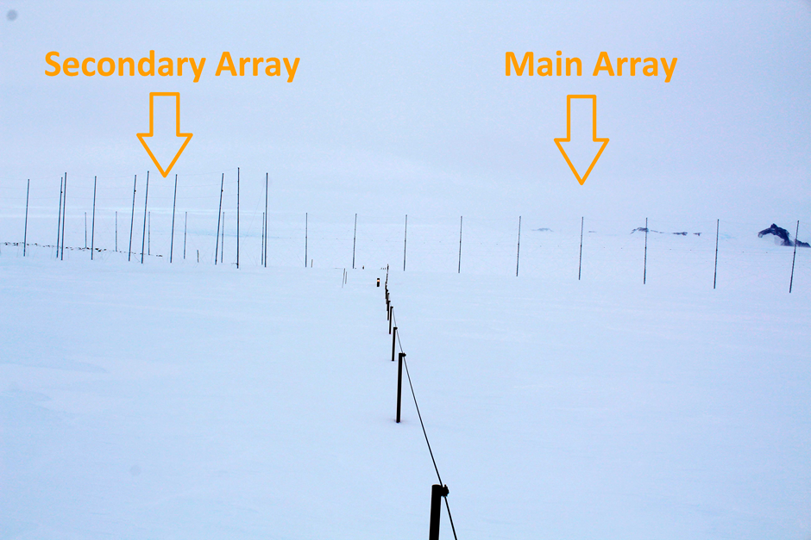

Figure . The main and secondary arrays of the radar.

### Main array

The 16 masts supporting the main antenna array are held up by stay ropes. These ropes need to be always maintained. The masts in the main array are equipped with rungs for climbing to do repairs.

Whenever maintenance is being done, proper procedure should be followed. Refer to the SANSA fall protection plan for more details. Training for working at heights is mandatory and at least two trained persons must be present when maintenance is being done. At least one qualified person should be geared up and, on the ground, while anyone is climbing, in case it is necessary to perform a rescue.

### Secondary array

The 13 masts supporting the 4 secondary array antennas are held up by stay ropes. These also need to be always maintained. These masts are not equipped with rungs for climbing, so any repairs to these must be done with the help of a crane CAT and cherry picker basket.

Proper safety procedures for this must be followed too. They are like that for climbing, so refer to the fall protection plan again for more details.

Please note that the secondary array antennas are not currently installed, but that the masts and stay ropes need to be maintained in any case to prevent any damage to the infrastructure.

## Hardware

The radar has a main antenna array consisting of 16 antennas and a secondary array with 4 antennas. Each of these antennas is driven by a transceiver box, interconnected by the radar’s server network. The antennas are hexagonal and consist of two halves, as shown in *Figure 3* below.

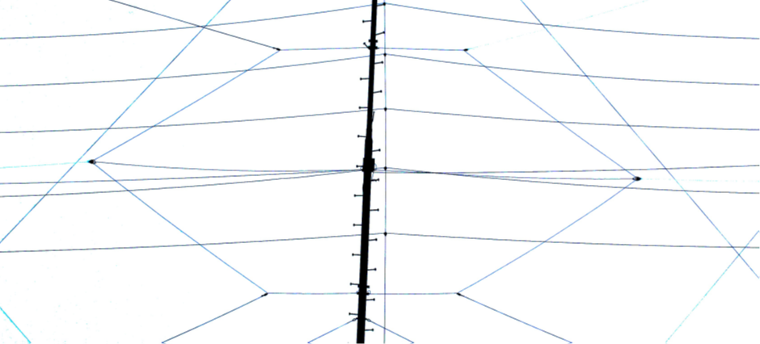

Figure . A radar antenna.

*Figure 4* shows the basic layout for the front and back of a radar transceiver box. The configuration of the server and network setup is demonstrated in the diagram shown in *Figure 5*. The local radar network consists of a timing, control, and monitoring network.

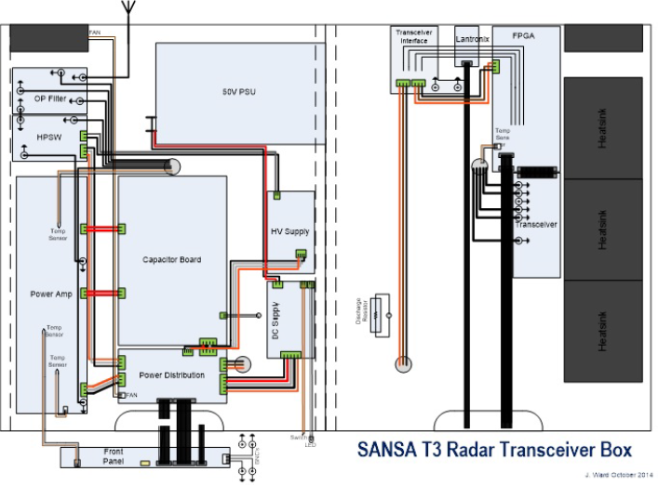

Figure . Radar transceiver box layout.

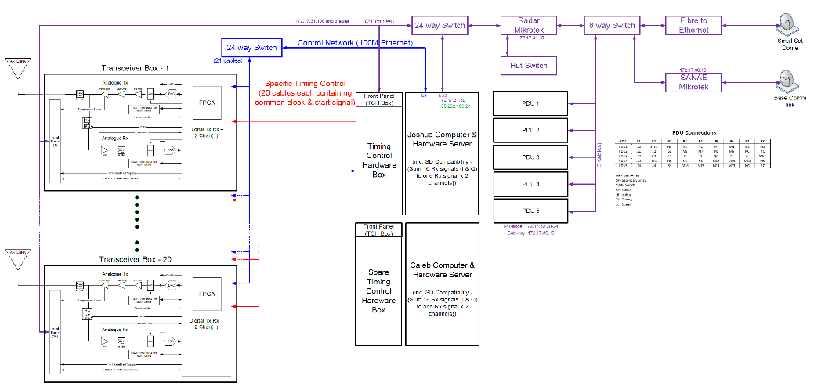

Figure . Network layout.

## Software

The radar has several components that requires their own specialized software:

* RST - Radar control software installed on the radar server
* VHDL code installed on the T3 FPGA Board
* C Code installed on the Front Panel processor
* VHDL code installed on the HPSW FPGA

The RST software is mostly written in C and was developed to produce a standard data product for all SuperDARN radars. All the source code is available, but rarely gets updated or changed.

The VHDL source code for the T3 FPGA board isn’t fully available but is currently being adapted to allow for operation of the secondary array too. The file for reprogramming the board is available, should one of them start giving problems.

C code for the Front Panel’s Zilog processor is available and will need to be updated from time to time. This code is responsible for monitoring the state of each transceiver box: On the Front Panel LCD as well as remotely via the server’s monitoring network.

The high-power switches have a small CPLD installed on them for monitoring, control, and communication purposes. The VHDL code for these chips is available but shouldn’t require any changes. Should one of the boards give problems, they can be reprogrammed.